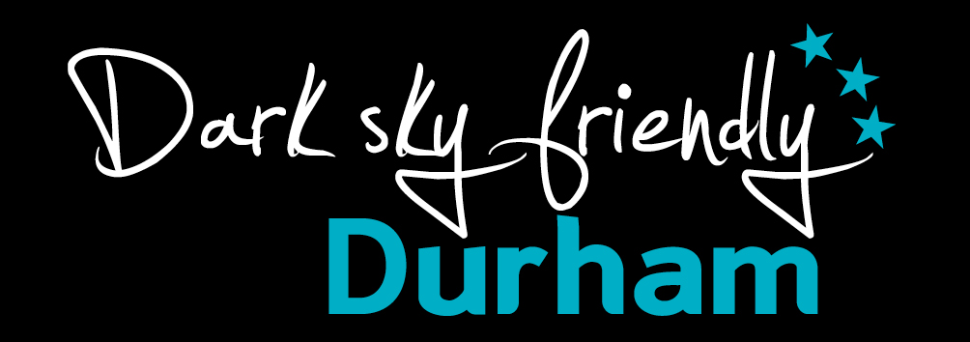

Dark Sky Friendly self-assessment form

Visit County Durham has developed this charter mark to recognise businesses that support star gazing tourism and who wish to be work with Visit County Durham to promote this growing sector.

Please complete the information below. All relevant essential criteria must be met to enable use of the logo and to be included within Visit County Durham’s promotional activity. If you have any queries, please contact Lucy Wearne on 03000 261225.

Essential; | Yes | No | N/a
Provide guests with information about what equipment and clothing to bring to enjoy the night skies
Provide star gazing information: e.g. leaflets, websites, event information etc
Include information about star gazing in your product record for thisisdurham.com
Provide refreshments – available at suitable times
Desirable; | Yes | No | N/a
Provide equipment that guests can use to view the stars – e.g. binoculars, telescopes etc.
Accept late arrivals post star-gazing events and activities
Are flexible with guests – consider requests for late check in/out or late breakfasts/evening meal
Dark Sky Friendly lighting

Working with Visit County Durham

Name:

Business name:

Business Address:

Telephone number:

Email:

Website:

Signed: Date:

By completing this self-assessment you agree to work positively and pro-actively alongside the staff and representatives of Visit County Durham and our partners. You agree to meet the requirements of the Dark Sky Friendly accreditation at all times and understand that you may be asked to renew this commitment annually.

Visit County Durham reserves the right to withdraw the use of the charter mark if the criteria are not met.
Return completed forms to;
Email: lucy.wearne@visitcountydurham.rorg

